A Sensitivity and Identifiability Framework for Testing the Hepatic Arterial Buffer Response After Paediatric Liver Transplantation

Highlights
- Dimensionally consistent pi-filter model tests HABR after paediatric LDLT
- Propagated parameter non-identifiability is not the dominant uncertainty
- Vessel-calibre growth sensitivity spans results of opposite sign
- Framework specifies what serial measurements would resolve HABR's role
- Doppler indices alone cannot quantify HABR's contribution post-transplant
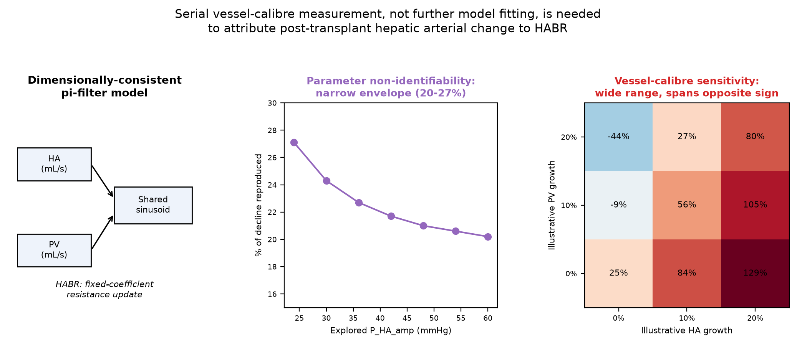
Graphical abstract.

Abstract
Post-transplant Doppler surveillance is routinely interpreted using mechanistic hypotheses -- most often the hepatic arterial buffer response (HABR) -- without models that account for their own structural uncertainty. We present a computational-physiology framework that does: a dimensionally-consistent lumped-parameter ('pi-filter') hepatic circulation model, in which every state variable is a genuine volumetric flow related to Doppler velocity only through an explicit, literature-sourced vessel-calibre assumption, paired with two structural sensitivity analyses -- propagation of the model's own parameter non-identifiability, and propagation of unmeasured vessel-calibre change -- rather than a single best-fit result. Applied to a real cohort of 41 infants after left-lateral-segment living-donor liver transplantation for biliary atresia, the hepatic-arterial branch's calibration is non-identifiable (three parameters fit to two Doppler targets); propagating the whole explored parameter family gives a relatively narrow result envelope (20-27% of the measured decline in hepatic artery peak systolic velocity reproduced by postoperative day 30). Propagating illustrative postoperative growth in portal and hepatic-artery calibre -- neither measured beyond day 1 in the source cohort -- moves the same quantity from -44% to +129% across a modest illustrative range, and this dominance of calibre uncertainty over parameter non-identifiability is preserved whether growth is modelled as a pure velocity-observation effect or with additional geometric remodelling of arterial inertance. The practical result is not a quantitative attribution of HABR's role, but a specification of what would make one possible: serial hepatic-arterial and portal-vein calibre measurement, which this analysis shows matters more than any further model refinement. We argue this identifiability-and-sensitivity approach, not the specific HABR finding, is the transferable contribution, applicable to any Doppler-based mechanistic hypothesis test in post-transplant or post-surgical vascular surveillance.

Keywords
hepatic arterial buffer response; liver transplantation; paediatric; Doppler ultrasound; lumped-parameter model; identifiability analysis; sensitivity analysis; computational physiology

1. Introduction
Doppler ultrasound surveillance after paediatric liver transplantation is interpreted largely through qualitative physiological reasoning: a falling hepatic artery resistive index (RI) or peak systolic velocity (PSV) is commonly attributed to the hepatic arterial buffer response (HABR), the intrinsic tendency of hepatic arterial flow to counteract changes in portal venous flow, mediated by adenosine washout in the periportal space of Mall [1]. This attribution is rarely tested against a mechanistic model, and even where models exist, they are rarely checked for whether their own calibration is unique, or how sensitive their conclusions are to quantities the clinical data do not measure. This paper develops and demonstrates a general computational-physiology approach to both problems, using HABR attribution after paediatric living-donor liver transplantation (LDLT) as the test case.
Prior work from this group modelled HABR using an electrical-analog ('pi-filter') lumped-parameter circulation model with an empirical quadratic regulation function [2], subsequently applied in unpublished draft form to an adult-to-child left-lateral-segment (LLS) transplantation scenario [3,4]. We rely on these two unpublished sources for specific calibration pressure/flow values because no equivalent published dataset for this exact clinical scenario was located; this dependence is a genuine limitation (Section 4).
Chen et al. report serial hepatic artery and portal vein Doppler measurements in 41 infants (4-18 months, biliary atresia) before and after LLS-LDLT, at postoperative day (POD) 1, 7, 14, and 30 [5]. Hepatic artery PSV and RI both fall over this month, attributed qualitatively to HABR by the authors, without a quantitative mechanistic test.
This study makes two contributions, one methodological and one substantive, and we present the methodological contribution as the primary one. First (methods), we show how to build a lumped-parameter Doppler-interpretation model that is dimensionally consistent throughout -- every flow variable on a common physical basis, related to measured velocity only through an explicit, sourced vessel-calibre assumption -- and how to propagate, rather than merely disclose, the model's own parameter non-identifiability and its sensitivity to calibre quantities the clinical data do not measure. Second (application), applying this framework to the Chen et al. cohort shows that parameter non-identifiability is a minor source of uncertainty here, while vessel-calibre uncertainty is large enough to change the sign of the conclusion -- meaning HABR's quantitative contribution to this cohort's trajectory cannot currently be established, and specifying exactly what measurement (serial vessel calibre) would change that is itself a useful, actionable output for future study design.

2. Methods

2.1 Dataset
Chen et al. [5] (doi:10.3389/fbioe.2022.903385) report a retrospective study of 41 infants (22 male, 19 female; median age 5 months, range 4-18) with biliary atresia undergoing LLS-LDLT, with uncomplicated postoperative courses. Doppler measurements were taken pre-transplant and at POD1, 7, 14, and 30 (Table 1).
Time | PSV_HA (cm/s) | RI_HA | PVV (cm/s)
Pre-transplant | 73.32 +/- 22.31 | 0.77 +/- 0.09 | 16.88 +/- 5.69
POD1 | 53.10 +/- 16.02 | 0.61 +/- 0.05 | 30.80 +/- 8.67
POD7 | 47.02 +/- 10.05 | 0.59 +/- 0.03 | 30.05 +/- 8.80
POD14 | 42.29 +/- 10.38 | 0.59 +/- 0.05 | 28.39 +/- 6.47
POD30 | 38.51 +/- 7.63 | 0.59 +/- 0.01 | 26.71 +/- 7.93
Table 1: Real cohort data ([5], mean +/- SD, n=41).

2.2 Pi-filter lumped element and generic circulation model
The circulation is represented with a two-port 'pi-filter' lumped element (series inductor L and resistor Rs between ports; an identical shunt capacitor-resistor branch at each port). A single-lobe topology has hepatic arterial (HA) and portal venous (PV) pi-filters both feeding a shared sinusoidal node, draining through a hepatic venous (HV) pi-filter to a fixed inferior-vena-cava reference pressure P_IVC (Figure 1). Two time variables are used and never conflated: tau, time within one cardiac cycle (the ODE integration variable, tau in [0,T), T=60/HR seconds); and 'day' (POD), indexing which of several INDEPENDENT simulations is run, each an independently-converged periodic state.
L_HA dQ_HA/d(tau) = P_HA(tau) - Rs_HA*Q_HA - P_sinus
C_sinus dP_sinus/d(tau) = Q_HA + Q_PV - Q_HV - P_sinus/Rp_sinus
L_HV dQ_HV/d(tau) = P_sinus - Rs_HV*Q_HV - P_hv
C_hv dP_hv/d(tau) = Q_HV - (P_hv - P_IVC)/Rp_hv_out
with P_HA(tau) = P_HA_mean + P_HA_amp*sin(2*pi*tau/T). All pressures are in mmHg; all flows (Q) are in mL/s during this integration; tau is in seconds. Under this basis: Rs and Rp in mmHg*s/mL; L in mmHg*s^2/mL; C in mL/mmHg (Table 3). Reported mean/peak flow values elsewhere in this paper are converted to mL/min (multiplying the mL/s quantity by 60) for readability; Section 2.2.1 states which convention each equation uses explicitly to avoid notational ambiguity. In the GENERIC configuration (this section), Q_PV is itself a state, governed by L_PV dQ_PV/d(tau) = P_PV - Rs_PV*Q_PV - P_sinus, with P_PV constant. In the POST-LDLT configuration (Section 2.4), this equation is disabled; Q_PV is a prescribed constant for each day's simulation, overwritten between days to that day's real measured value.
The generic configuration was calibrated against previously-derived calibration targets [3,4] (portal driving pressure 13 mmHg, mean arterial pressure 57.5 mmHg [range 42.4-72.6], sinusoidal pressure 5.37 mmHg, hepatic venous pressure 4.07 mmHg, portal flow 300 mL/min, hepatic arterial flow 31.93 mL/min, hepatic venous flow 322.5 mL/min). Rs_PV, Rs_HA, Rs_HV were solved exactly via Ohm's law on the time-averaged circuit from these targets; agreement (within 2%, Figure 3) is close by construction. Inertance/compliance parameters (Table 3) were chosen, not fit, for plausible pulsatility.
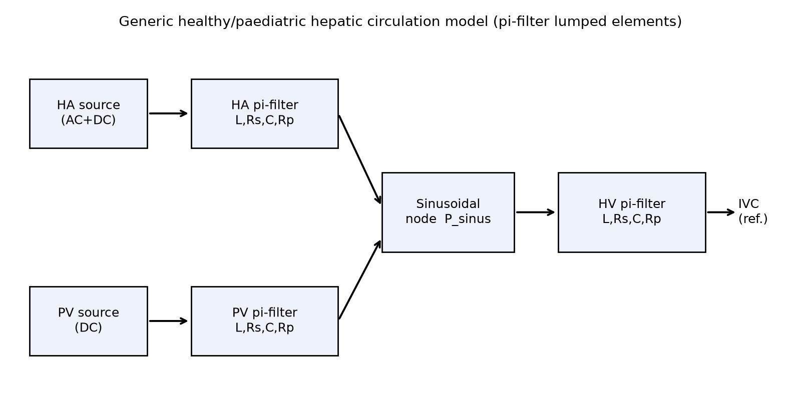
Figure 1: Pi-filter circulation model schematic.
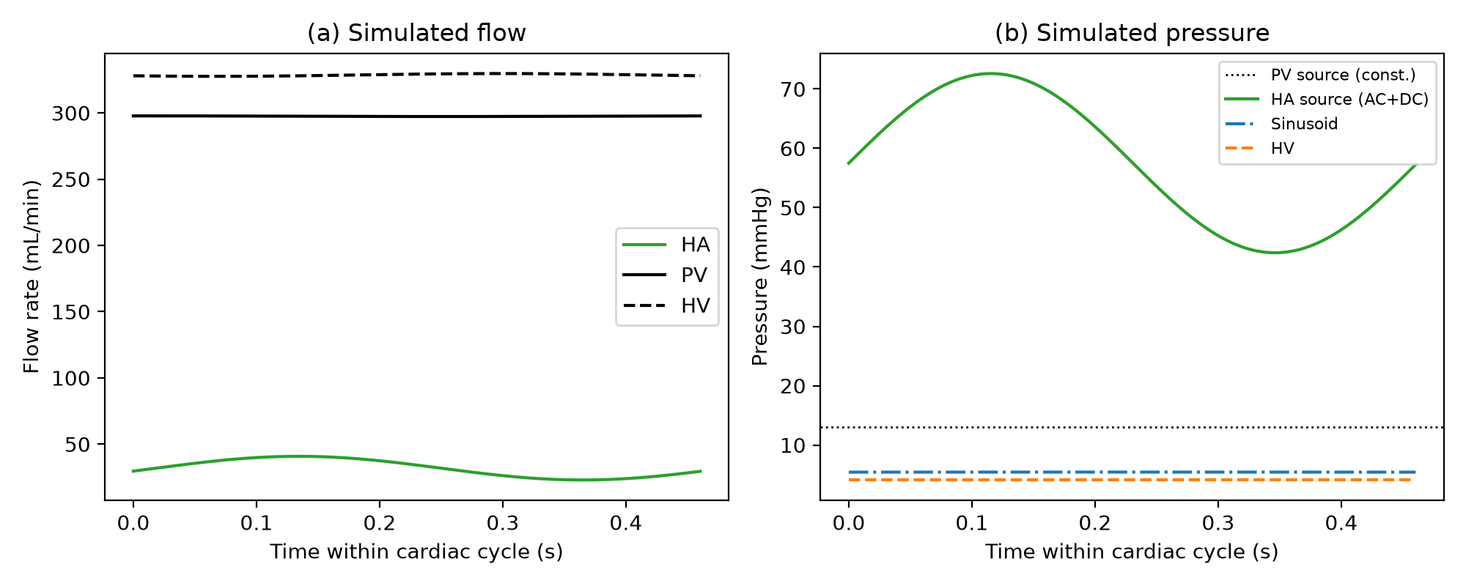
Figure 2: Generic model simulated flow (a) and pressure (b), one cardiac cycle.
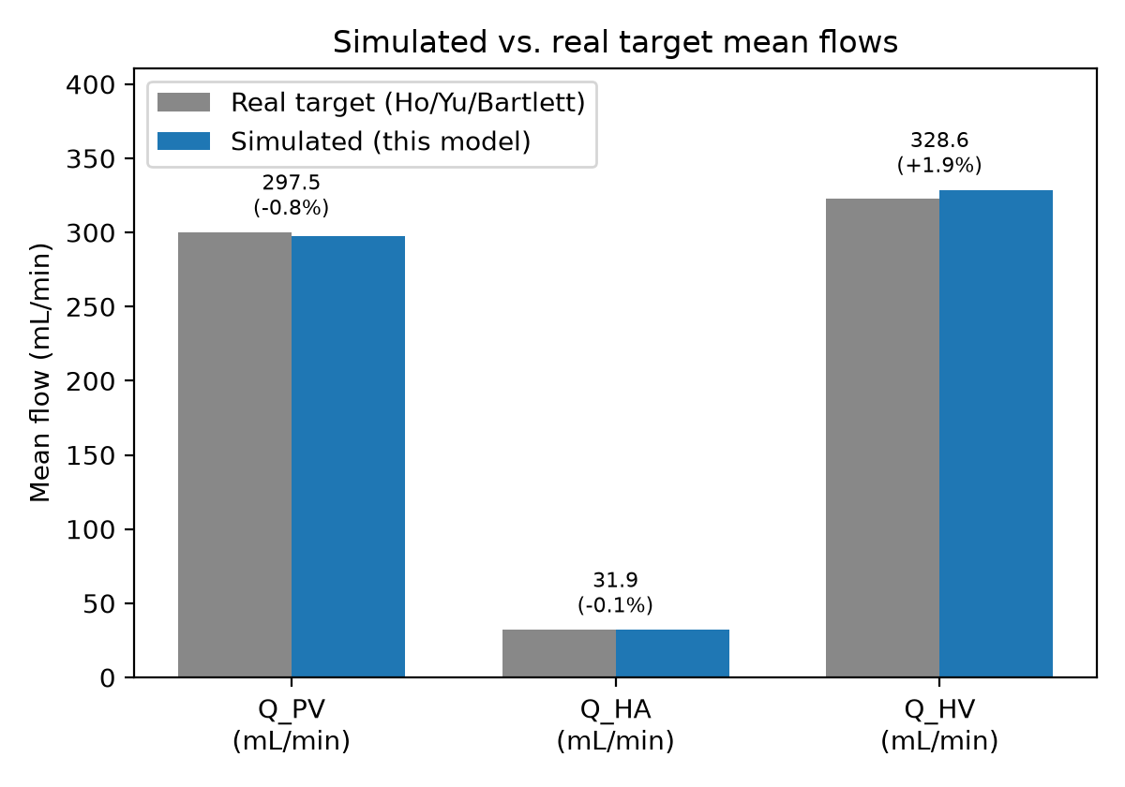
Figure 3: Generic model mean flows vs. calibration targets (within 2% by construction).

2.2.1 Mapping simulated flow to Doppler velocity
Q_HA(tau), as it appears in the ODE above, is in mL/s. It is related to Doppler velocity via an assumed hepatic-artery cross-sectional area A_HA: v_HA(tau) = Q_HA(tau) / A_HA (mL/s divided by cm^2 gives cm/s directly, since 1 mL = 1 cm^3; no additional unit-conversion factor is needed or applied here). One-line dimensional check: the model's POD1 mean HA flow (Section 3.2) is 25.0 mL/min = 0.417 mL/s; dividing by A_HA = 0.0113 cm^2 gives a mean velocity of 36.9 cm/s, consistent with (below) the simulated PSV of 53.1 cm/s, as expected for a peak-over-cycle-mean ratio in a pulsatile waveform. A_HA is set from a diameter of 1.2 mm (giving A_HA = 0.0113 cm^2), the mean right hepatic artery diameter reported in a healthy, non-jaundiced infant control group (mean age 67 days) in a paediatric ultrasound reference study [6] -- an assumption for this cohort's graft artery, not a measurement of it. Section 2.7 tests both this baseline value's published uncertainty (1.0-1.4 mm) and separately, whether it changes over the postoperative month.
A further caveat: v = Q/A gives a cross-sectional MEAN velocity, whereas spectral Doppler PSV is conventionally read as a spatial peak, not a cross-sectional average; the source cohort's own portal-flow formula (Section 2.4) applies a factor (0.57) specifically to convert their measured (peak-like) PVV toward a mean velocity for flow calculation, and no directly analogous, independently-sourced factor is applied here on the hepatic-artery side. Because the POD1 fit (Section 2.4) calibrates directly against measured PSV_HA, this profile-shape discrepancy is absorbed into the fitted parameters rather than left as a visible residual. We therefore do NOT treat the resulting POD1 mean HA flow (Section 3.2) as an independently interpretable absolute physiological quantity -- only relative (percent) changes in flow, and RI (a ratio, invariant to a fixed unmodelled profile factor as long as it does not itself change over time), are used in the conclusions that follow.

2.3 Fixed-coefficient HABR relationship and its exact application
HABR is represented, as in the prior work it is drawn from, by a discrete resistance-update rule: changeIha = 0.0007102*x^2 + 0.5492*x, x being the percent DECREASE in portal flow relative to a reference day. These coefficients are imported, not re-estimated here -- a 'fixed-coefficient' relationship, not a 'parameter-free' one, since Rs_HA, L_HA, P_HA_amp, and A_HA are all calibrated or assumed elsewhere (Table 3).
Exact procedure, for target day d relative to reference day POD1: x(d) = (Q_PV(POD1) - Q_PV(d)) / Q_PV(POD1) * 100 (Q_PV from Section 2.4's flow formula, each day's real measured PVV). changeIha(d) = 0.0007102*x(d)^2 + 0.5492*x(d). Q_HA_target(d) = Q_HA_ref * (1 - changeIha(d)/100), Q_HA_ref being the model's periodic-steady-state mean HA flow at the POD1 anchor. Rs_HA(d) is found by Brent's method (scipy.optimize.brentq; initial bracket [0.3, 3.0] times the POD1-fitted Rs_HA, expanded geometrically by 0.7/1.4 up to 40 times if no sign change is found; convergence tolerance 1e-8; treated as a failure, and excluded, if no sign change is found within the expansion limit) such that simulating with P_HA_mean, P_HA_amp, and L_HA held at their POD1-fitted values and Q_PV fixed at Q_PV(d) gives a periodic-steady-state mean HA flow equal to Q_HA_target(d). In the CONTINUOUS scenario, the reference day is always POD1. In the ACUTE-THEN-FROZEN scenario, this is performed once, for d=POD7; Rs_HA(POD14)=Rs_HA(POD30)=Rs_HA(POD7).

2.4 Post-LDLT model anchoring, and its non-identifiability
Q_PV(d) is computed via the source cohort's reported formula, PVF = pi*r^2*0.57*PVV*60 (r=diameter/2 in cm, PVV in cm/s), yielding a quantity with units of mL/min despite the source paper's 'per 100 g graft' label, which includes no graft-mass term; graft weight was not available to us. Section 2.7 tests whether this ambiguity matters, by scaling Q_PV as if graft mass were 50-200 g. Portal diameter is reported only at pre-transplant (0.44 cm) and POD1 (0.46 cm); held at the POD1 value for POD7-30 in the primary analysis.
Rs_HA, L_HA, and P_HA_amp are calibrated JOINTLY at POD1 against real measured PSV_HA and RI_HA -- three unknowns, two targets, necessarily non-unique. Fixing P_HA_amp at the generic model's literature value (15.1 mmHg) made RI_HA=0.61 unreachable for any tested (Rs_HA, L_HA) combination (achievable RI capped near 0.48 across a wide grid search); P_HA_amp is therefore a third free parameter. Section 2.7 generates the admissible family within a prespecified, explored range of P_HA_amp (approximately 23.5 mmHg, the threshold below which no exact fit exists, to 60 mmHg, a practical bound for this analysis) and propagates every member through POD30, rather than reporting one arbitrarily-selected solution; we refer to this as the admissible family WITHIN THIS RANGE, not the entire admissible family, since no upper mathematical bound on P_HA_amp exists.

2.5 Three HABR-application scenarios, as alternatives
HABR's adenosine-washout kinetics equilibrate within minutes to a few hours, but describe continuous coupling between portal flow and periportal adenosine concentration, not a single event that occurs once and then stops [1]. Fast equilibration therefore does not by itself justify confining HABR's application to any particular window of the postoperative month. Three scenarios are presented as alternatives, not as one preferred model with the others as baselines:
- Continuous: Rs_HA(d) set from Section 2.3's update at every day d.
- Acute-then-frozen: Rs_HA set once, for POD7, then held fixed. Motivated by, not proven by (Section 2.6): mean RI_HA is numerically flat (0.59) from POD7 through POD30.
- Null: Rs_HA frozen at its POD1 value throughout.

2.6 Testing whether RI is really flat
We compared RI between time points using an unpaired Welch's t-test and a 95% confidence interval calculated from the published summary statistics (mean, SD, n=41) -- a conservative approximation, since the cohort is repeated-measures on the same 41 patients. This is an ordinary unpaired comparison of summary statistics, not an equivalence test.

2.7 Structural sensitivity analyses
Four analyses address the model's structural uncertainties -- the methodological core of this study:
- POD1 identifiability envelope: the admissible (Rs_HA, L_HA, P_HA_amp) family within P_HA_amp in [23.5, 60] mmHg (19 values, spaced 2 mmHg apart from 24 to 60, plus the 23.5 mmHg threshold point) is propagated through the continuous scenario to POD30. Each point is fit by minimising squared relative error in PSV and RI jointly (Nelder-Mead, tolerance 1e-8 on parameters / 1e-14 on the objective; a fit is accepted only if the residual objective is below 1e-6, otherwise excluded), warm-started from the previous point's solution. To check whether 60 mmHg understates the envelope, we additionally solved points up to 300 mmHg (a supraphysiological pressure amplitude, useful only to test mathematical convergence): the result stabilises asymptotically (20.2% at 60 mmHg to 18.8% at 300 mmHg), so extending the explored range further would change the envelope only marginally.
- Illustrative portal/hepatic-artery calibre-growth sensitivity: assumed diameter growth by POD30 (0/10/20/30/40% for each vessel independently, plus a 2D grid varying both together, 0/10/20% each) is propagated through the continuous scenario, using the representative POD1 fit. We call these growth values illustrative, not plausible or probable: no source measures serial vascular calibre change in this population, which is precisely the premise motivating this analysis. Two variants are distinguished explicitly: (i) KINEMATIC DILUTION ONLY -- only A_HA (used in the flow-to-velocity conversion, Section 2.2.1) is changed for the growth calculation; Rs_HA is still re-solved via Section 2.3's HABR flow-target procedure exactly as in the primary analysis, but L_HA and the underlying circuit are otherwise unaffected by the assumed growth -- this is the PRIMARY analysis reported in Results 3.5, and is a velocity-observation effect, not a full physical simulation of arterial remodelling; (ii) EXPLORATORY STRUCTURAL REMODELLING -- L_HA is additionally scaled geometrically, L_HA(d) = L_HA_pod1 / (1+g)^2 for assumed radius growth fraction g (inertance scaling as 1/r^2 for a fixed-length vessel), with Rs_HA still solved via the same HABR flow-target procedure using this grown L_HA; this is a secondary, exploratory check, reported in Results 3.5, of whether the kinematic-only simplification materially misleads. Because resistance remains determined by the HABR flow target rather than an independent radius-resistance law, this variant evaluates inertial remodelling but is not a complete geometric reconstruction of vascular growth. The hepatic-artery baseline diameter's own published uncertainty (1.0-1.4 mm) is tested with the POD1 anchor RE-FIT for each candidate baseline (re-fitting is necessary because A_HA enters the POD1 velocity calibration directly), and combined with the growth sensitivity to check whether the growth-sensitivity shape depends on the assumed baseline.
- Graft-mass Q_PV scaling: Q_PV scaled by 0.5-2.0x (as if graft mass were 200-50 g), holding 0% diameter growth, to check whether the unresolved graft-mass-normalization ambiguity (Section 2.4) materially affects the primary result.

2.8 Illustrative sensitivity intervals (secondary)
Monte Carlo intervals (200,000 draws, POD1 and each later mean sampled independently with SD/sqrt(41)) for the 'fraction of decline reproduced' under the representative POD1 fit, reported as illustrative sensitivity intervals, not confidence intervals: independent sampling is the wrong covariance structure for this repeated-measures cohort, no PVV or model-parameter uncertainty was propagated, and no draws were discarded (including near-zero or negative simulated measured-decline draws, which produce a heavy-tailed distribution at POD7). We regard these as secondary to the structural analyses in Section 2.7, which are this study's principal methodological contribution.

2.9 Model parameters
Parameter | Value | Units | Source
HR | 130 | beats/min | assumed, representative infant heart rate
P_PV_src (generic) | 13.0 | mmHg | calibration target [3,4]
P_HA_mean (generic) | 57.5 | mmHg | calibration target [3,4]
P_IVC | 2.0 | mmHg | assumed (not reported in source)
Rs_PV (generic) | 1.526 | mmHg*s/mL | solved exactly from generic targets; reused post-LDLT
Rs_HV (generic) | 0.242 | mmHg*s/mL | solved exactly from generic targets; reused post-LDLT
Rp_hv_out (generic) | 0.385 | mmHg*s/mL | solved exactly from generic targets; reused post-LDLT
Rs_HA (generic) | 97.96 | mmHg*s/mL | solved for generic model; NOT reused post-LDLT (2.4)
L_HA (generic) | 2.0 | mmHg*s^2/mL | assumed for generic model; NOT reused post-LDLT (2.4)
A_HA (hepatic artery area) | 0.0113 | cm^2 | [6] (1.2 mm diameter, healthy infant control group) -- assumed, not measured for this cohort
Rs_HA (POD1, representative family member) | 127.92 | mmHg*s/mL | jointly fit to real POD1 PSV_HA/RI_HA with L_HA, P_HA_amp -- 3 unknowns/2 targets, non-unique; explored admissible family within P_HA_amp = 23.5-60 mmHg (19 points, Rs_HA range 127.92-127.93, L_HA range 2.16-22.23 mmHg*s^2/mL) propagated in Section 2.7/3.3
L_HA (POD1, representative family member) | 5.80 | mmHg*s^2/mL | jointly fit, as above
P_HA_amp (POD1, representative family member) | 27.43 | mmHg | jointly fit, as above
L_PV, L_HV | 0.01, 0.02 | mmHg*s^2/mL | assumed
C_sinus, C_hv | 2.0, 2.0 | mL/mmHg | assumed
Rp_sinus | 500 | mmHg*s/mL | assumed
Portal diameter (POD1) | 0.46 | cm | [5]; held fixed POD7-30 in primary analysis
PV velocity-to-flow factor | 0.57 | dimensionless | [5]
Integration | forward Euler, 400 steps/cycle | - | -
Convergence criterion | <1e-4 relative change, consecutive cycles | - | -
Table 3: Full model parameter list, with explicit physical units throughout.

2.10 Candidate residual mechanisms: literature search
A literature search (PubMed/EuropePMC, citations verified against primary sources or the EuropePMC metadata API before use) was conducted for real, plausible, non-HABR mechanisms, presented as testable hypotheses, not identified mechanisms.

3. Results

3.1 Generic model calibration
The generic pi-filter model reproduced the calibration targets within 2% by construction (Figure 3) and the qualitative waveform pattern reported in the source work (Figure 2).

3.2 POD1 anchor: a representative, non-unique fit
One representative member of the admissible family (Rs_HA=127.92 mmHg*s/mL, L_HA=5.80 mmHg*s^2/mL, P_HA_amp=27.43 mmHg; Table 3) reproduces measured PSV_HA (53.10 cm/s) and RI_HA (0.610) exactly by construction, with a periodic-steady-state mean HA flow of 25.0 mL/min (0.417 mL/s; 36.9 cm/s cross-sectional mean velocity, Section 2.2.1). We do not treat this flow value as an independently interpretable plausibility check: it depends on the assumed HA area and an unmodelled velocity-profile factor, both absorbed into the fit.

3.3 Parameter non-identifiability, propagated: a minor source of uncertainty
Across the 19-point explored family (P_HA_amp 24-60 mmHg, plus the 23.5 mmHg threshold point), Rs_HA varies only from 127.92 to 127.93 mmHg*s/mL and the resulting mean HA flow is unchanged at 25.0 mL/min, while L_HA ranges from 2.16 to 22.23 mmHg*s^2/mL -- L_HA and P_HA_amp trade off against each other to preserve the same pulsatility ratio at POD1, while Rs_HA (and the mean flow it implies) is well-constrained by the two POD1 targets regardless. Propagating every member through POD30 gives a relatively narrow envelope: 20.2-27.1% of the measured PSV_HA decline reproduced (Figure 6), stabilising toward about 18.8% if the explored P_HA_amp range is extended to a supraphysiological 300 mmHg (Section 2.7). Despite Rs_HA and mean flow being nearly constant across the family, the PSV-based 'fraction reproduced' still varies measurably (20.2-27.1%) because PSV depends on the PULSATILE SHAPE of the waveform, not only its mean: different (L_HA, P_HA_amp) combinations that reproduce the same POD1 mean flow and PSV/RI can still respond differently in peak-to-mean ratio once Rs_HA is subsequently adjusted at POD30 to hit a new HABR-implied mean-flow target, which is why the envelope is narrow but not exactly zero. This result is itself methodologically important: it demonstrates that a model can be non-identifiable in its full parameter space while still being well-constrained in the specific output quantity a downstream analysis depends on -- a distinction only visible by propagating the family, not by reporting a single fit.
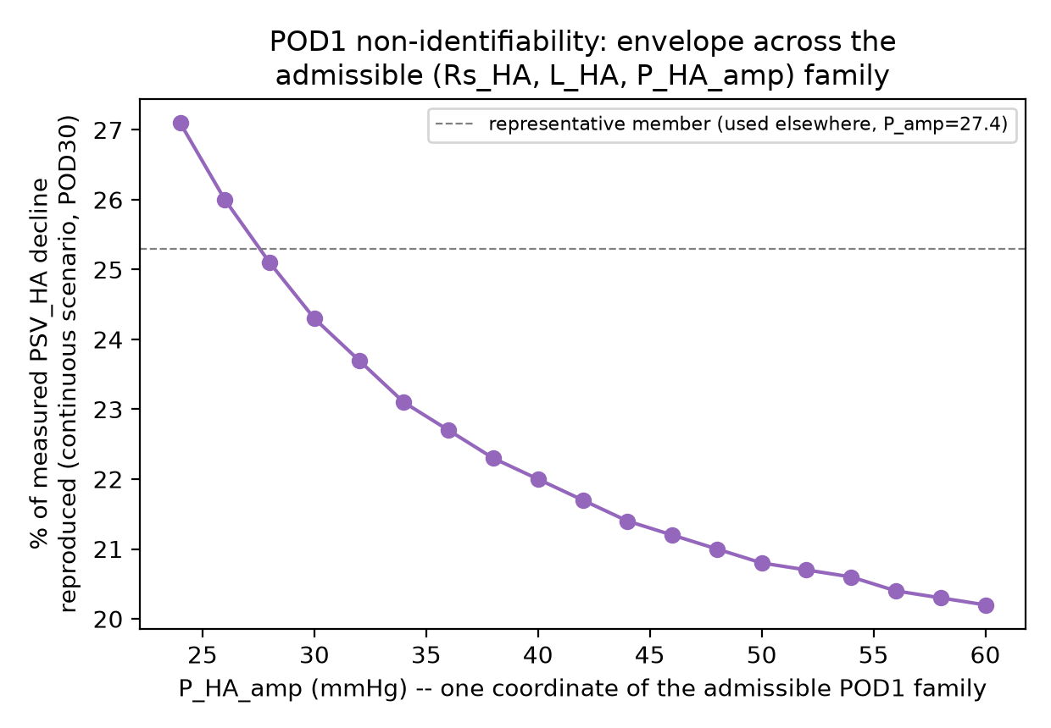
Figure 6: '% of decline reproduced' across the admissible POD1-fit family within the explored P_HA_amp range.

3.4 Three scenarios (representative fit)
Using the representative fit, under zero assumed calibre growth, the three scenarios diverge by POD30 (Figure 4, Table 2): the null scenario predicts PSV_HA would rise slightly (53.10 to 53.27 cm/s); both HABR scenarios predict a fall (continuous to 49.41 cm/s, acute-then-frozen to 52.57 cm/s). Section 3.5 shows this directional difference is contingent on the calibre assumptions.
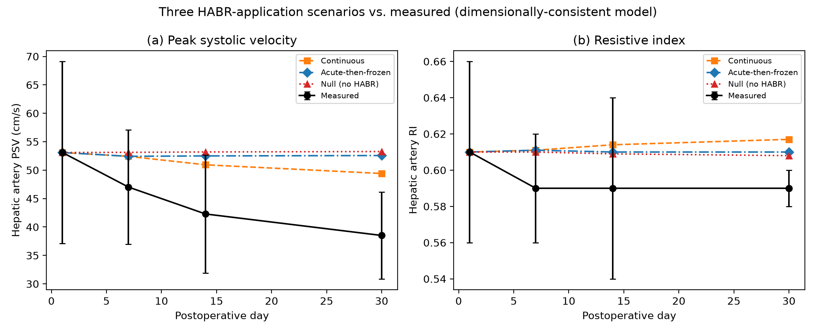
Figure 4: Measured vs. all three scenarios.
Day | Measured PSV (cm/s) | Continuous | Acute-then-frozen | Null
POD1 | 53.10 | 53.10 | 53.10 | 53.10
POD7 | 47.02 | 52.43 | 52.43 | 53.13
POD14 | 42.29 | 50.94 | 52.50 | 53.20
POD30 | 38.51 | 49.41 | 52.57 | 53.27
Table 2: Simulated PSV_HA under all three scenarios vs. measured.

3.5 Illustrative vessel-calibre sensitivity exceeds parameter-fit uncertainty
The hepatic artery's OWN baseline-diameter uncertainty (1.0-1.4 mm, re-anchored at POD1 for each value) has little effect when calibre is held constant thereafter (23.7-26.4% reproduced across this range). Postoperative GROWTH is different: hepatic-artery diameter growth alone (portal growth held at 0%, kinematic-dilution-only variant) moves the result from 25.3% (no growth) to 191.2% at 40% growth -- in the OPPOSITE direction to portal-diameter growth, which reverses its sign (Figure 7). A 2D grid varying both (Figure 8) ranges from -44% (20% portal growth, no HA growth) to +129% (no portal growth, 20% HA growth) across an ILLUSTRATIVE, unvalidated 0-20% growth range in each vessel -- we do not claim this range is clinically probable, only that it is a modest range worth showing the consequences of, since no source measures serial calibre change in this population. The growth-sensitivity shape is consistent across the tested baseline diameters (at 20% HA growth: 129.5%, 128.8%, 127.7% reproduced for 1.0, 1.2, 1.4 mm baseline respectively) -- the conclusion does not depend on which baseline value within its published uncertainty is assumed. This directly demonstrates that, for this application, vessel-calibre uncertainty -- not parameter non-identifiability -- is the quantity that must be constrained before HABR's contribution can be attributed.
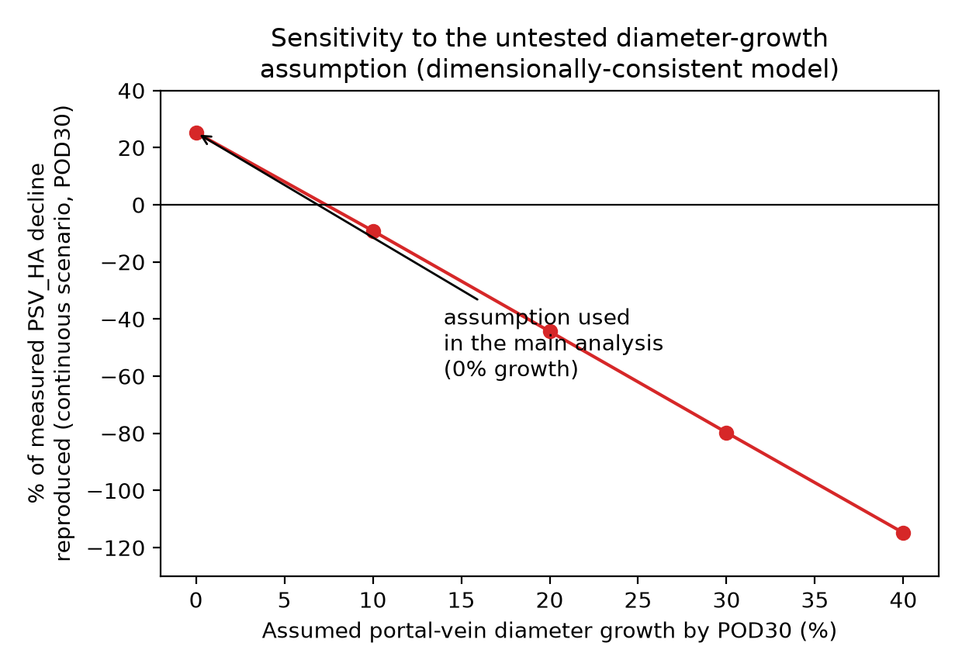
Figure 7: Portal-diameter-growth sensitivity.
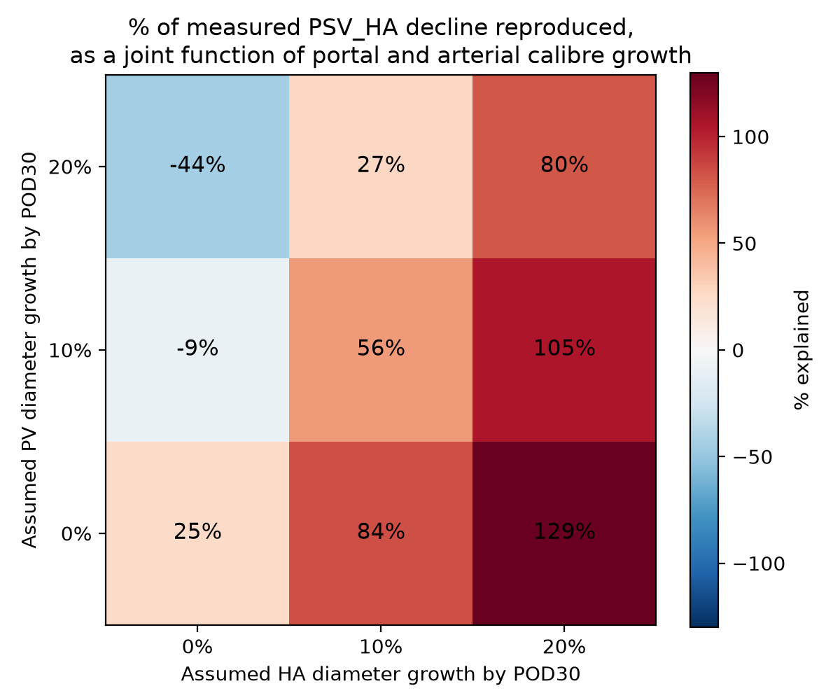
Figure 8: Joint portal x hepatic-artery calibre-growth sensitivity (illustrative range).
Because the primary HA-growth analysis above is a kinematic dilution only effect (only A_HA changes; Section 2.7), we checked whether this simplification materially misleads by additionally scaling L_HA geometrically in an exploratory structural remodelling variant (Table 4). The two give qualitatively similar, quantitatively close results (e.g. at 40% HA growth: 191.2% kinematic-only vs. 185.6% structural remodelling) -- the kinematic-only simplification is not wildly misleading for this specific comparison, though it remains, precisely, a velocity-observation effect rather than a complete physical simulation of how arterial growth would alter circuit impedance.
HA growth | Kinematic-only (% reproduced) | Structural remodelling (% reproduced) | PSV(POD30), kinematic vs. structural
0% | 25.3% | 25.3% | 49.41 vs. 49.41
10% | 84.1% | 80.5% | 40.84 vs. 41.36
20% | 128.8% | 123.7% | 34.31 vs. 35.06
30% | 163.6% | 158.0% | 29.24 vs. 30.05
40% | 191.2% | 185.6% | 25.21 vs. 26.03
Table 4: Kinematic-dilution-only vs. exploratory structural-remodelling variants of the HA-growth sensitivity (portal growth held at 0%).
By contrast, the graft-mass Q_PV-scaling ambiguity (Section 2.4, 2.7) has almost no effect: scaling Q_PV by 0.5-2.0x changes the POD30 result only from 25.5% to 25.1%. This specific ambiguity, while conceptually valid, is not a material source of uncertainty in this model -- a further illustration that the framework distinguishes which uncertainties matter, not merely that uncertainty exists.

3.6 RI comparison
POD1 vs. POD7 RI_HA differ by 0.020 (95% CI [0.002, 0.038], p=0.032); POD7 vs. POD30 do not detectably differ (95% CI [-0.010, +0.010], p=1.00) -- this interval EXCLUDES a true difference as large as 0.020. We describe RI as 'not detectably changing' after POD7, and treat the acute-then-frozen scenario as a hypothesis motivated by, not demonstrated by, this observation.

3.7 Illustrative sensitivity intervals (secondary)
Under the continuous scenario and the representative POD1 fit: approximately 11% [5%, 64%] at POD7, 20% [13%, 43%] at POD14, 25% [18%, 40%] at POD30. Regarded as of limited additional value beyond the structural analyses above.

3.8 Candidate mechanisms for any residual decline
Whatever the model does not reproduce may reflect a real physiological mechanism not included here, model misspecification, or measurement variability -- this study cannot distinguish between these possibilities. Two literature-grounded physiological candidates are presented as testable hypotheses:
- Systemic haemodynamic normalization: resolves within days (3-5 postoperative days in one adult cohort, n=57; [7]; related timescales 4 days to 2 weeks, [8]).
- Graft-regeneration-driven vessel-calibre dilution: graft mass increases substantially over weeks (~1.7-fold by 2 weeks; [9]), which Section 3.5 shows would materially affect Doppler velocity if it applies to vessel calibre specifically -- though quantitative regeneration data are inconsistent across the (adult, non-LLS) studies located ([10]; [11]), graft volume does not necessarily translate into proportional arterial growth near an anastomosis, and paediatric LLS grafts are often not classically undersized [12], so even the direction of expected calibre change is not established for this population.
Other unmodelled, plausible contributors: systemic cardiac output/pressure-amplitude changes beyond the fixed assumption used here; postoperative oedema; arterial spasm; anastomotic geometry; Doppler insonation angle or sampling-location variation; sedation; heart rate. None were assessed here.

4. Discussion

4.1 A transferable framework for Doppler-based mechanistic hypothesis testing
The methodological contribution of this study is a way of testing mechanistic hypotheses against post-transplant (or, more broadly, post-surgical) Doppler surveillance data that treats the model's own uncertainty as a first-class output, not an afterthought: (i) enforce dimensional consistency throughout, so that every state variable is on a common physical basis and Doppler velocity enters only through an explicit, sourced calibre assumption; (ii) when calibration is non-identifiable, propagate the admissible parameter family rather than reporting one arbitrarily-selected solution; (iii) test sensitivity to every quantity the clinical data do not measure directly, not only the one a specific hypothesis happens to highlight. Applied here, step (ii) shows the model's own non-identifiability is a minor concern (Section 3.3), while step (iii) shows an unmeasured quantity -- vessel calibre, on both the portal and hepatic-arterial side -- is large enough to reverse the conclusion's sign (Section 3.5). This ordering is itself a finding: it would have been easy to treat the non-identifiability as the main caveat and stop there, when in fact it is not what limits this analysis.

4.2 What this means for HABR attribution in this cohort
Under the model's stated assumptions (constant vessel calibre after POD1, an assumed hepatic-artery area, one representative member of a non-identifiable parameter family), the fixed-coefficient HABR relationship predicts a fall in hepatic arterial velocity. We do not conclude that HABR's quantitative contribution to this cohort's trajectory can be established: the vessel-calibre sensitivity (Section 3.5) shows the result is not robust to a plausible, unmeasured change in either vessel's calibre, whether modelled as a pure velocity-observation effect or with additional structural remodelling.

4.3 Required future measurement, framed as a positive output
Rather than treating the absence of a quantitative HABR attribution as simply a negative result, this analysis specifies precisely what would resolve it: serial measurement of both hepatic-artery and portal-vein calibre (diameter or cross-sectional area), at the same postoperative time points already collected for velocity and RI in studies like [5]. This is a modest addition to an existing surveillance protocol -- ultrasound calibre measurement, not a new imaging modality -- and the sensitivity analysis here quantifies how much it would matter (a 10% unmeasured calibre change is enough to reverse the sign of the conclusion), which is a stronger justification for collecting it than intuition alone would provide. We consider this specification, together with the identifiability-propagation and dimensional-consistency methodology (Section 4.1), the paper's principal contribution -- more durable than any single quantitative HABR estimate, which the same missing data would in any case make premature.

4.4 Limitations
The circulation is a single lobe with lumped elements, not the fuller multi-generation vascular tree used in some prior work by this group. The generic model's calibration targets and the HABR coefficients come from two unpublished manuscripts [3,4]; we searched for published alternatives and did not find equivalent real paediatric LLS-LDLT data. The assumed hepatic-artery area (Section 2.2.1) is sourced from a different, native, non-transplant population [6]; the mean-velocity-versus-Doppler-PSV distinction means the resulting absolute flow values should not be over-interpreted. The structural-remodelling variant (Section 3.5) scales inertance geometrically but leaves Rs_HA determined by the HABR flow-target procedure rather than by an independent geometric resistance law. The pre-transplant to POD1 transition is not modelled, since it is a discrete organ-replacement event rather than a same-vessel flow perturbation. Graft-to-recipient weight ratio is unknown for this cohort. All comparisons use group-level data; the illustrative sensitivity intervals (Section 3.7) are not proper confidence intervals for this cohort's repeated-measures structure.
We would not currently recommend this framework for individual-patient interpretation. Its demonstrated value is at the cohort/study-design level: identifying, before further data collection, which uncertainties are worth resolving and which are not.

5. Conclusion
We present a dimensionally-consistent lumped-parameter framework for testing mechanistic Doppler-interpretation hypotheses, combining explicit vessel-calibre-to-velocity mapping with propagation of both parameter non-identifiability and calibre-assumption sensitivity. Applied to hepatic arterial buffer response attribution after paediatric LDLT, the framework shows that parameter non-identifiability is a relatively minor uncertainty (20-27% of the measured decline reproduced across the explored family) while illustrative vessel-calibre growth -- unmeasured beyond POD1 in the available data -- dominates, spanning a range wide enough to include the opposite sign. HABR's quantitative contribution to this cohort's observed trajectory therefore cannot be established from current data; what can be established is exactly what serial measurement would make that possible. We propose this identifiability-and-sensitivity approach as a general template for testing mechanistic hypotheses against post-surgical Doppler surveillance data.

Declarations

Funding
[To be completed by the corresponding author before submission.]

Competing interests
[To be completed by the corresponding author before submission.]

Ethical approval
This is a secondary analysis of de-identified data reported in Chen et al. [5], collected under the ethics approval described in that publication; no new human-subjects data were collected.

Data availability
The code underlying this analysis will be deposited in a public repository before publication.

References
[1] Eipel C, Abshagen K, Vollmar B. Regulation of hepatic blood flow: the hepatic arterial buffer response revisited. World J Gastroenterol 2010;16(48):6046-6057. doi:10.3748/wjg.v16.i48.6046
[2] Ho H, Sorrell K, Bartlett A, Hunter P. Modeling the hepatic arterial buffer response in the liver. Med Eng Phys 2013;35:1053-8. doi:10.1016/j.medengphy.2012.10.008
[3] Yu HB, Bartlett A, Hunter P, Ho H. Hybrid 0D-1D blood flow simulation for virtual liver transplantation in paediatric recipients. Unpublished manuscript.
[4] Ho H, Yu HB, Bartlett A. Computational simulations for the hepatic arterial buffer response after liver graft transplantation. Unpublished manuscript.
[5] Chen X, Xiao H, Yang C, Chen J, Gao Y, Tang Y, Ji X. Doppler evaluation of hepatic hemodynamics after living donor liver transplantation in infants. Front Bioeng Biotechnol 2022;10:903385. doi:10.3389/fbioe.2022.903385
[6] Kim WS, Cheon JE, Youn BJ, Yoo SY, Kim WY, Kim IO, Yeon KM, Seo JK, Park KW. Hepatic arterial diameter measured with US: adjunct for US diagnosis of biliary atresia. Radiology 2007;245(2):549-555. doi:10.1148/radiol.2452061093
[7] Plevak DJ, Southorn PA, Narr BJ, Winter PB, Rettke SR. Hyperdynamic circulatory state after liver transplantation. Transplant Proc 1993;25(2):1837-8.
[8] Dashti SH, Kasraianfard A, Ebrahimi A, Nassiri-Toosi M, Pakshir MS, Rahimi M, Jafarian A. Hemodynamic changes and early recovery of liver graft function after liver transplantation. Int J Organ Transplant Med 2020;11(1):1-7.
[9] Byun SH, Yang HS, Kim JH. Liver graft hyperperfusion in the early postoperative period promotes hepatic regeneration 2 weeks after living donor liver transplantation. Medicine (Baltimore) 2016;95(46):e5404. doi:10.1097/MD.0000000000005404
[10] Marcos A, Fisher RA, Ham JM, Shiffman ML, Sanyal AJ, Luketic VA, Sterling RK, Fulcher AS, Posner MP. Liver regeneration and function in donor and recipient after right lobe adult to adult living donor liver transplantation. Transplantation 2000;69(7):1375-1379.
[11] Zhang Y, Li B, He Q, Chu Z, Ji Q. Comparison of liver regeneration between donors and recipients after adult right lobe living-donor liver transplantation. Quant Imaging Med Surg 2022;12(6):3184-3192. doi:10.21037/qims-21-1077
[12] Vargas PA, Goldaracena N. Alternatives to left lateral segment for pediatric liver transplantation, or required surgeon toolkit? Hepatobiliary Surg Nutr 2024;13(2):376-378. doi:10.21037/hbsn-23-671

